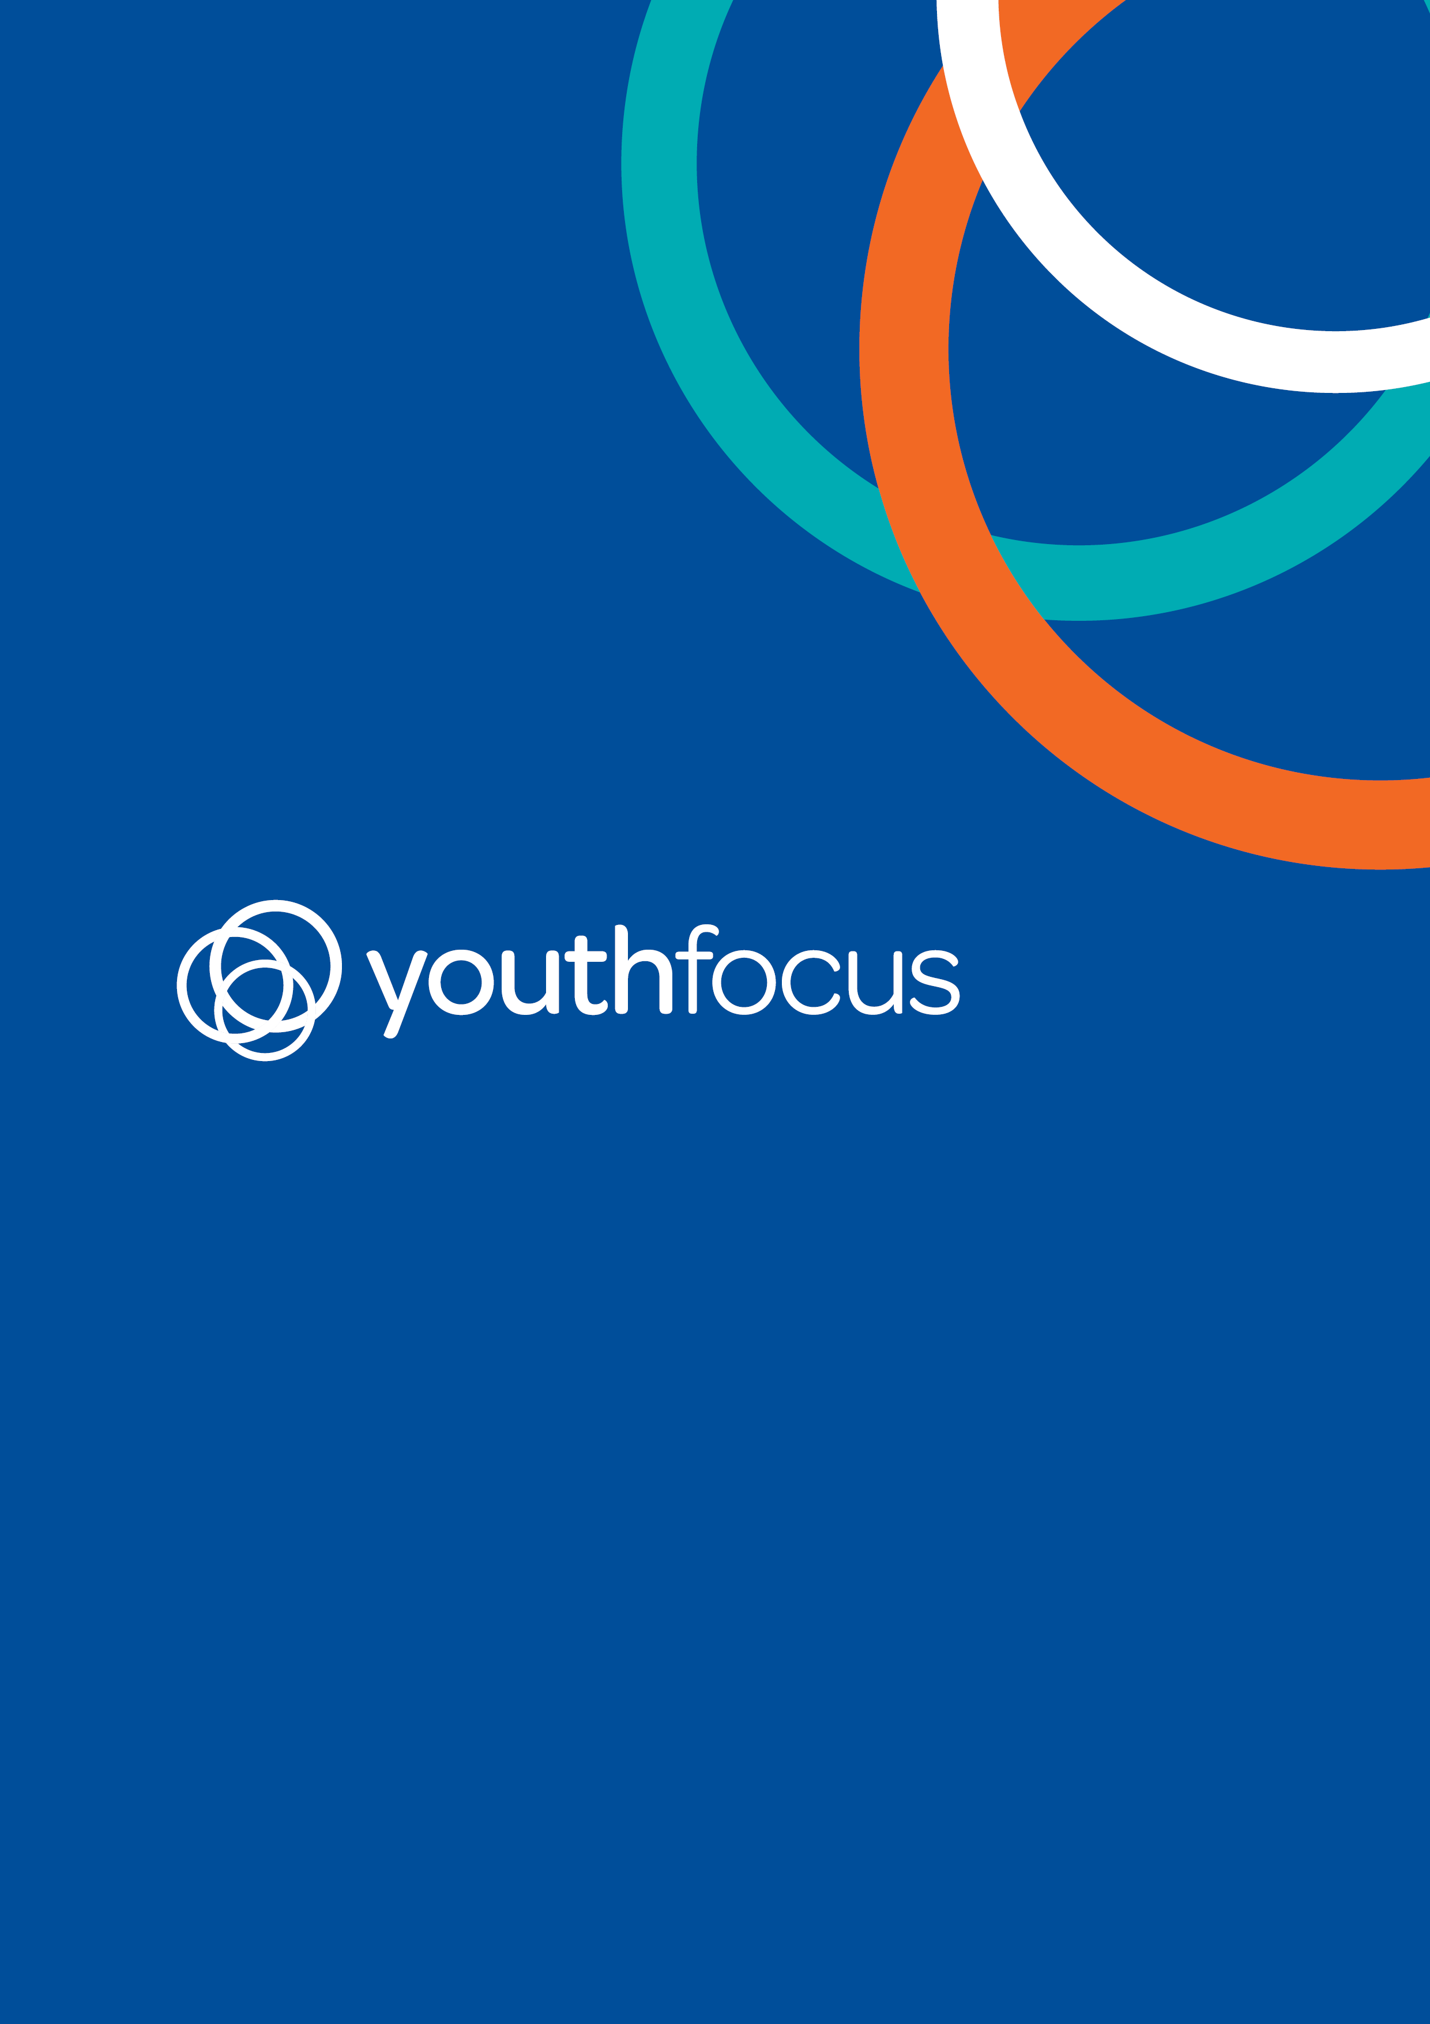

Mentoring Program Application Pack
Mentoring Program

Application Pack 2019
Thank you for your interest in becoming a Mentor with Youth Focus. Please take the time to read through this application pack before completing.
The role of a Mentor is to show support to their Mentee, by being a positive role model while assisting the young person to develop new skills and enhance existing skills in the following, and other, areas:

- Self-esteem;
- Trust;
- Communication;
- Relationships;
- Goal setting;
- Conflict resolution;
- Problem solving; and
- Life skills.
Our mentoring relationships are a 12 month commitment whereby Mentors are required to meet with their Mentees a minimum of twice per month for between 1 and 3 hours, depending on the chosen activity.

Checklist
☐ I have read and agree to the contents of the Application Pack
☐ I have completed the Application Form
☐ I have had completed the two written reference checks (professional and personal) and requested they forward them to the contact details provided

Youth Focus: Who We Are
Youth Focus is an independent West Australian for purpose organisation.
The Youth Focus mission is to put a stop to youth suicide and depression by creating a world where young people are confident, empowered and feel a great sense of connection and belonging in their communities.
We do this through early intervention and prevention services, working with young people aged 12 to 24 to help them overcome issues associated with depression, anxiety, self-harm and suicidal thoughts. A team of highly trained and skilled clinicians provide free, unlimited and professional face-to-face counselling and complimentary mental health services.

Youth Focus: What We Do
Youth Focus aims to understand young people and their difficulties within the broader context of their lives which includes family, friends, school and their local community. This understanding acknowledges the effect of past experiences, the significance of current issues and circumstances and the nature of adolescence as a life stage.
We aim to provide our free services in a way that is youth friendly, flexible, needs driven and personalised. We offer our services from our offices located in Burswood, Joondalup, Rockingham, Bunbury and Albany, as well as via schools, outreach locations and web counselling.
Each year about 2,000 young people aged 12 to 24 will visit one of these offices or outreach locations state-wide to get help. The average length of counselling engagement is approximately six months.
In addition to youth counselling, Youth Focus’ other core services include:
- Mentoring Program;
- Peer Support Program;
- Workplace Training;
- Mental Health Education;
- School Education Programs; and
- Community Engagement.

Youth Counselling
Counsellors work exclusively with the young person, or where appropriate, in collaboration with their family.
Youth Focus provides a friendly, confidential and professional service for young people who are in need of counselling and support. Our counsellors are trained professionals with the skills necessary to assist young people in identifying coping strategies to deal with issues associated with suicide, depression and self-harm.
Youth counselling appointments are free of charge and available at our offices or on an outreach basis – where counsellors meet with clients at their school or another location eg: selected youth centres.
Counsellors will assist young people experiencing feelings such as:
- Feeling unhappy, moody or irritable a lot of the time;
- feeling empty or numb;
- Losing interest and pleasure in activities that were once enjoyed;
- Change in appetite, eating habits or weight;
- Change in sleeping habit;
- Tiredness, lack of energy and motivation, difficulty concentrating;
- Feeling bad, worthless or guilty or being overly critical of oneself;
- Negative or ‘down on yourself’ thoughts;
- Thoughts of death or suicide;
- Periods of intense fear or anxiety; unwanted thoughts and fears;
- Uncontrollable and unrealistic worry about everyday situations; and
- Deliberate acts of self-harm or injury as a way of coping with difficult or painful feelings.

Mentoring with Youth Focus
The Mentoring Program supports young people 12- 24 years who are already engaged in counselling with Youth Focus.
The young person’s counsellor assesses the need for a mentor based on the young person's goals and interests. They then collaborate with the Youth Programs Coordinators to match the young person with a mentor based on their interests, gender, location, and the mentor’s ability to meet the needs of the young person.
The mentoring program here at Youth Focus has been shown to be effective in supporting young people to meet their full potential and can encourage the development of resiliency. Additionally, the mentoring program has demonstrated numerous benefits to mentors in their own professional and personal development.
Mentors are carefully assessed and chosen to provide positive role modelling while assisting the young person to develop new skills and enhance existing skills in the following, and other, areas:
- Self-esteem;
- Trust;
- Communication;
- Relationships;
- Goal setting;
- Conflict resolution;
- Problem solving; and
- Life skills.
At the heart of Youth Focus Mentoring, lies an affirmation of being a collaborative and mutually beneficial partnership.
Mentoring with Youth Focus specifically involves a mentor over the age of 21 years being matched with a young person already engaged in counselling. This relationship lasts for a period of 12 months and mentor and young person see each other for regular social outings a minimum of twice per month for 1-3 hours.

Mentor Accountability
Youth Focus are part of the Australian Youth Mentoring Network (AYMN), and currently collaborate with other youth mentoring organisations on the WA Youth Mentoring Network, including:
- Department of Communities;
- Ed Connect;
- YMCA;
- Ladder;
- Wadjuk Northside
- The Smith Family;
- Leading Youth Forward;
- Ngala Midwest Gascoyne ; and
- Murdoch University.

The AYMN mission is to foster the growth and development of high quality mentoring programs for young people in Australia by providing a national base of collaboration, support, guidance and expertise.
As a member of AYMN, Youth Focus’ Mentoring Program has been developed in line with, and continues to meet, the standards of Australian Mentoring Benchmarks.

Eligibility
Those enquiring about becoming a Youth Focus Mentor must meet the following eligibility requirements:
- Be at least 21 years of age;
- Be willing and able to apply for a National Police Clearance (less than 3 months old), Working With Children Check (current) and First Aid training to the satisfaction of the Youth Programs Coordinators;
- Be willing to adhere to Youth Focus’ policies and procedures;
- Be available to commence a mentoring relationship within 12 months of completing the Youth Focus Mentoring Training, and remain in the mentoring relationship for 12 months; and
- Must not have a sibling, parent, spouse and/or family member currently employed with or accessing clinical services with Youth Focus.

Mentoring Relationships
The process of being matched with a Youth Focus client begins with:
- Counsellor discusses the mentoring program with the young person, and collaboratively they refer the young person into the mentoring program;
- Counsellor submits the Client Referral Form to the Youth Programs Coordinator; and
- Youth Programs Coordinator begins the matching process.

The matching process is conducted in consultation with the counsellor, and focuses on the needs of the young person as noted in their application. The process considers:
- The preferences and goals of the young person, mentor and their guardian (where appropriate);
- The mentor’s experience, skills and expertise;
- Other shared interests between the young person and mentor;
- Similarity of personalities and temperaments between the young person and mentor;
- Gender or ethnicity, if these are important to the young person;
- Any special needs of the young person; and
- Geographic closeness and compatibility of meeting times.

Once a mentor has been contacted by Youth Programs Coordinator for a potential match, and has confirmed availability for the next 12 months:
- An initial match meeting is scheduled with the mentor, young person, counsellor and YPC;
- Facilitated by the YPC, all parties are explained their roles and responsibilities and the young person and mentor are
- In the initial match meeting, the first catch up is scheduled

Ongoing match support, including regular monitoring and feedback to manage risk and create opportunities to celebrate the relationship is integral to the success of mentoring relationships. As a result:
- After each catch up, Mentors are required to debrief within 24 hours to the YPC with a brief update regarding what they did, how it went, and any concerns or questions they might have;
- YPC’s coordinate individual 3 monthly reviews with the mentor and young person to provide a safe space for reflection, feedback and future planning; and
- YPC’s provide ongoing support to Mentors via phone and/or email as necessary.
Youth Focus Mentoring Relationships are purposely planned to end after a period of 12 months. Occasionally due to unforeseen or extenuating circumstances, relationships may end sooner, or be extended.
Where possible, a closure meeting is scheduled and facilitated by the YPC with all involved parties to provide the mentor young person with a chance to reflect and celebrate what has been gained through the mentoring relationship.
Youth Focus views the closure meeting to be as important as the initial match meeting, both to honour the achievement of completing their relationship, and to maintain clear boundaries within the mentoring program. The young person and mentor will not continue to be in contact with each other once the mentoring relationship has ended.
A mentoring relationship ending is a final opportunity to provide good modelling to the young person, being that endings to relationships are healthy and can be positive with warm reflections of the time together as opposed to negative attachment to the relationship ending.

Mentoring Program Application Form
Personal Details
Contact Details
First Name
Last Name
Address
Suburb
Identified Gender
Date of Birth
Email Address
Phone Number

Emergency Contact
Name
Relationship to you
Contact number

About You
What do you do for work and/or study?
_____________________________________________________________________________________________________________________________________________________________________________________________________________________________________________________________________________________________________________________________________________________________________________

Tell us a bit about yourself outside of work and/or study
_____________________________________________________________________________________________________________________________________________________________________________________________________________________________________________________________________________________________________________________________________________________________________________

Do you have any disabilities/medical conditions that may limit your ability to participate in certain activities? If yes, please provide details of what you will need for us in order to accommodate your needs
_____________________________________________________________________________________________________________________________________________________________________________________________________________________________________________________________________________________________________________________________________________________________________________

How far (minutes) are you prepared to travel from your home address to meet a young person?
_____________________________________________________________________________________________________________________________________________________________________________________________________________________________________________________________________________________________________________________________________________________________________________

Are you able to complete one-day Mentor Training on Saturday March 16th, 2019?
_____________________________________________________________________________________________________________________________________________________________________________________________________________________________________________________________________________________________________________________________________________________________________________

Screening Process

Do you have a National Police Clearance less than 3 months old | ☐ Yes | ☐ No | ☐ Willing to obtain
Do you have a current Working With Children Check? | ☐ Yes | ☐ No | ☐ Willing to obtain
Do you have current First Aid training? | ☐ Yes | ☐ No | ☐ Willing to complete

Written Reference – Personal
Youth Focus is a West Australian, not for profit community based organisation working with young people 12-24 years of age, in prevention and early intervention of suicide, depression and self-harm.
Mentors are carefully assessed and chosen to provide positive role modelling while assisting the young person to develop and enhance skills in areas such as self-esteem, communication, goal setting, social skills, trust, relationship building, conflict resolution and problem solving.
When matched in a relationship, Mentors commit to 12 months of meeting with their mentee on a fortnightly basis for between one and three hours, depending on their chosen activity.

Referee Name
Referee Contact Number
Relationship to Applicant
Relationship length

Please describe the personal attributes of the Applicant that you feel would be beneficial to them as a Mentor to a Young Person aged 12-24 years.
_____________________________________________________________________________________________________________________________________________________________________________________________________________________________________________________________________________________________________________________________________________________________________________

What experience are you aware of that the Applicant has of working with young people?
_____________________________________________________________________________________________________________________________________________________________________________________________________________________________________________________________________________________________________________________________________________________________________________
What are the Applicant’s top two:
Strengths: | Weaknesses:

Please outline any considerations you feel might make it difficult for the Applicant to support a Young Person aged 12-24 years
_____________________________________________________________________________________________________________________________________________________________________________________________________________________________________________________________________________________________________________________________________________________________________________

Do you believe the Applicant is a trustworthy person?
_____________________________________________________________________________________________________________________________________________________________________________________________________________________________________________________________________________________________________________________________________________________________________________

Do you view the Applicant as a suitable role model for young people?
_____________________________________________________________________________________________________________________________________________________________________________________________________________________________________________________________________________________________________________________________________________________________________________

Thank you for completing this written reference in support of the Mentoring Program applicant. Please note that a Youth Programs Coordinator may be in contact with you in the coming weeks via telephone.
Please return this form to: Youth Programs Coordinator
Email: ypc@youthfocus.com.au
Phone: (08) 6266 4333

Signed | _____________ | Dated | ____/____/_______
Written Reference – Professional
Youth Focus is a West Australian, not for profit community based organisation working with young people 12-24 years of age, in prevention and early intervention of suicide, depression and self-harm.
Mentors are carefully assessed and chosen to provide positive role modelling while assisting the young person to develop and enhance skills in areas such as self-esteem, communication, goal setting, social skills, trust, relationship building, conflict resolution and problem solving.
When matched in a relationship, Mentors commit to 12 months of meeting with their mentee on a fortnightly basis for between one and three hours, depending on their chosen activity.

Referee Name
Referee Contact Number
Relationship to Applicant
Relationship length

Please describe the personal attributes of the Applicant that you feel would be beneficial to them as a Mentor to a Young Person aged 12-24 years.
_____________________________________________________________________________________________________________________________________________________________________________________________________________________________________________________________________________________________________________________________________________________________________________

What experience are you aware of that the Applicant has of working with young people?
_____________________________________________________________________________________________________________________________________________________________________________________________________________________________________________________________________________________________________________________________________________________________________________
What are the Applicant’s top two:
Strengths: | Weaknesses:

Please outline any considerations you feel might make it difficult for the Applicant to support a Young Person aged 12-24 years
___________________________________________________________________________________________________________________________________________________________________________________________________________________________

Do you believe the Applicant is a trustworthy person?
___________________________________________________________________________________________________________________________________________________________________________________________________________________________

Do you view the Applicant as a suitable role model for young people?
___________________________________________________________________________________________________________________________________________________________________________________________________________________________

Thank you for completing this written reference in support of the Mentoring Program applicant. Please note that a Youth Programs Coordinator may be in contact with you in the coming weeks via telephone.
Please return this form to: Youth Programs Coordinator
Email: ypc@youthfocus.com.au
Phone: (08) 6266 4333

Signed | _____________ | Dated | ____/____/________
Thank you

